November 16th, 2016
Centralized vs Decentralized HVAC System Cost & Efficiency in Schools
This article examines the efficiency of a centralized HVAC system vs a decentralized system in the following areas:
- Air Quality
- Energy Consumption
- Thermal Comfort
- Sound
- Maintenance
- Building Ceiling Plenum Height
For this discussion, we’re going to look at a centralized VAV system and unit ventilators for our decentralized system. Both systems will use chilled water and hot water for cooling and heating and both will incorporate an enthalpy energy recovery wheel and 100% economizer. Chilled water will be supplied by a high efficiency magnetic bearing chiller and heating water by a high efficiency condensing boiler in both cases. Flow control will be 2-way modulating valves on both the heating and cooling systems.
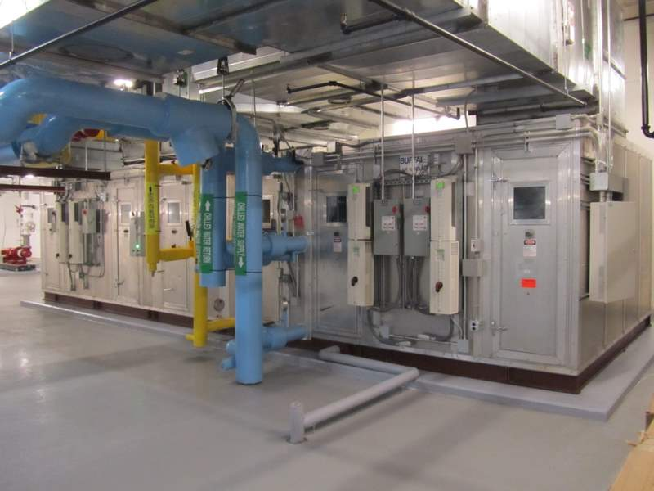
Fig. 1 24,000 CFM VAV Air Handling Unit with 48”H x 60”W main supply duct. Unit is 20’L x 8’W x 7’H
Volume 1 Issue 1
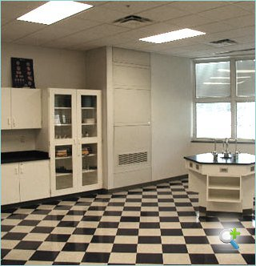
Fig. 2 Temspec 2000CFM ducted supply energy recovery unit ventilator 44”W x 30”D x 93”H.
1.0 Air Quality
We can break this down into two categories; air cleanliness – filtration, and air quality- CO₂ and VOC’s.
1.1 Air filtration - both systems will use a 2” per-filter and MERV 13 final filter.
1.2 Air Quality – Centralized – maintaining air quality in a central system can be challenging if you are monitoring the CO₂ and VOC levels only in a common return air. Obviously with this system, there is no way of guarantying either of these counts in any given classroom so some areas could be over-ventilated, which waste energy while others may be under ventilated. In my experience, most facilities are over-ventilated. In a case study conducted by McMaster University in Hamilton ON, on 6 of their facilities, the average CO₂ count was 480PPM which is just over the outdoor count of 402PPM when the target PPM was 900.
The table below shows the ventilation requirements for different space types.
TYPE | cfm/per person | cfm/ft²
Classroom (ages 5-8) | 10 | 0.12
Classroom (age 9 plus) | 10 | 0.12
Lecture Classroom | 7.5 | 0.06
Lecture Hall (Fixed Seats) | 7.5 | 0.06
Art Classroom | 10 | 0.18
Science Laboratories | 10 | 0.18
University/College Labs | 10 | 0.18
Computer Lab | 10 | 0.12
Restaurant /Dining room | 7.5 | 0.18
Hotel Bedroom | 5 | 0.06
Office Breakroom | 5 | 0.12
Office Main Entry | 5 | 0.06
Office space | 5 | 0.06
Office Reception Area | 5 | 0.06
Table 1: ASHRAE Standard 62.1 Ventilation Standards
The formula for calculating the ventilation rate is as follows:
V_{bz} = R_{p} x P_{z} + R_{a} x A_{z}
Where:
V_{bz} = outdoor airflow rate in zone (cfm)
R_{p} = outdoor air rate per person (cfm/person)
P_{z} = number of people in zone
R_{a} = area (cfm/ft²)
A_{z} = zone area
Example: 1000 sq ft classroom with 30 students.
V_{bz} = R_{p} x P_{z} + R_{a} x A_{z}
=10 x 30 + 1000 x .12
= 420CFM
1.3 Air Quality – Decentralized – monitoring occupancy, CO₂/VOC in a single zone is straight forward and ensures the lowest energy cost and highest air quality. Research shows the average classroom is utilized 35% of the typical 8 hour school day and of that 35%, the occupancy level is not at capacity. A unit ventilator can be programmed to provide the minimum fresh air volume of .12CFM/SQFT during un-occupied times and ramp up to meet the additional 10CFM/person when occupied by measuring the CO₂ level and maintaining it at the desired 900PPM. Demand Control Ventilation, DCV, can save 60 to 80% combined thermal and fan energy in a typical classroom with no compromise to occupant comfort. Over ventilating a space uses more energy, reduces equipment life and increases equipment maintence.
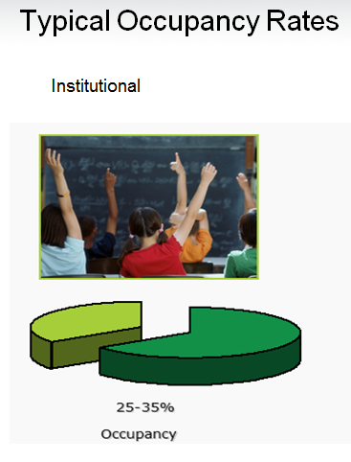
Fig. 3 Studies have shown that classrooms are occupied 25 -35% of the 8 hour school day
2.0 Energy Consumption
Energy is the single largest cost in a schools HVAC post construction budget so purchasing the highest efficiency equipment will obviously provide the lowest life cycle cost (LCC). The next step is to optimize the control strategy to further reduce the operating cost regardless of the system choice. In any system, we have thermal energy to produce the heating and chilled water, pumping energy to pump the chilled or heating water to the AHU or terminal unit, and fan energy to deliver the conditioned air to the space. We’ll compare these three energy consumers in each system. In both cases, we have energy recovery which in itself, offers significant energy savings and allows you to reduce the equipment capacity by the amount of energy recovered. Table 2 illustrates the energy savings with and without energy recovery with varying occupancies. ‘A” is the thermal energy percentage and ‘B’ is the fan energy expressed as a percentage.
S-Factor  (Occupancy) | Without energy recovery  A=0.55E₀ B=0.45E₀ | With energy recovery  A=0.33E₀  B=0.45E₀
1.0 | 0% | 22%
0.9 | 18% | 37%
0.8 | 33% | 51%
0.7 | 46% | 61%
0.6 | 57% | 70%
0.5 | 67% | 78%
Table 2 Energy savings based on occupancy (S-Factor) with and without energy recovery
2.1 Centralized System – the challenges that this system bring are space for the duct work and the amount of energy to move the air over long distances. Moving energy around a building with air takes up an enormous amount of space and is expensive due to the relatively low energy content of air compared to water or refrigerant. A typical classroom requires about 1000CFM to achieve an energy balance so if we have 24 classrooms our central station AHU would be designed to deliver 24000CFM. If the classrooms are 30ft x 30ft and the AHU located in the centre of the building, the AHU must produce enough static to supply 2000CFM over a minimum distance of 240ft. The pumping energy in centralized system is quite low due to the proximity of the pumps, chiller and AHU so this is an advantage.
For example:
2.1.1 Fan Energy - BHP = Q x TSPwg/u x 6356 BHP = brake horse power, TSPwg = total static pressure , u = fan efficiency
BHP = 2000 x 3.0 /.65 x 6356
BHP = 1.45 or 1.08 kW
2.1.2 Pump Energy – BHP = Flow (GPM) x Head (ft)/3960 x Pump Eff
=5 x 40/3960 x .6
= .084 HP or .062kW
2.1.3 Ventilation Energy - The second challenge with a central system is maintaining air quality in all zones. To achieve this, the minimum fresh air damper position is typically set to meet the ASHRAE Standard 62.1 which is this case is 420CFM (10 x 30 + .12 x 1000)
On a design cooling day, this load is 3,456 BTU or 1.01kW (Qtotal = 4.5 x CFM x delta h x (100%-70% energy recovery)
2.1.4 Centralized Summary - Since the time of day rate is highest between 11am and 4pm, the blended electrical rate is $0.185/kWh
The combined fan, pump and ventilation energy for this classroom for an 8 hour design day is Fan Energy + Pump Energy + Ventilation Energy or (1.08kW + .062kW + 1.01kW) x 8 hours x $0.185 = $3.18
2.2 Decentralized System – our air distribution system requires very little space and requires little energy to move over the short distance. As well, the supply air fan use a EC motor which has an inherent 10% efficiency advantage over the PSC motor used on the sentral station AHU.
Following the example above,
2.2.1 Fan Energy - BHP = 2000 x .75 /.65 x 6356
BHP = .36 or .27 kW
2.2.2 Pump Energy – The pumping energy will be greater with a decentralized system due to the higher head pressure required to meet the required flowrate at the furthest unit from the pump. BHP = Flow (GPM) x Head (ft)/3960 x Pump Eff
=5 x 60/3960 x .6
= .126 HP or .094kW
The unit ventilator is equipped with a enthalpy wheel for energy recovery which is operating at 70% minimum efficiency.
On a design cooling day, this ventilation load is 3,456 BTU or 1.01kW (Qtotal = 4.5 x CFM x delta h x (Qtotal – Qrecovered)
2.2.4 Decentralized Summary - The combined fan, pump and ventilation energy for this classroom for an 8 hour design day is Fan Energy + Pump Energy + Ventilation Energy or (.27kW + .094kW + 1.01kW) x 8 hours x $0.185 = $2.03
2.3 Energy Savings Summary The centralized system carries a classroom operating cost of $3.18 on a design day Vs the decentralized operating cost of $2.03 for a 36.2% savings.
If a DCV control strategy in introduced, additional operational savings can be realized. In addition, a diversity factor of 20% can typically be used which reduces the cooling and heating plant capacity. Table 3 illustrates this point well.
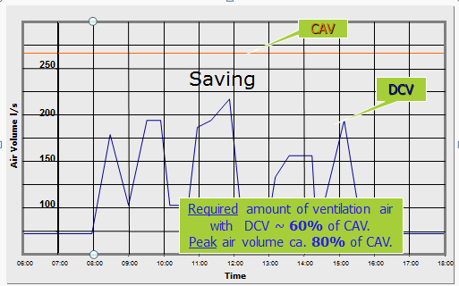
Table 3 Ventilation requirements over typical 8 hour period.
3.0 Thermal Comfort
Both systems offer very good comfort. Having said that, if the minimum position on the VAV box is set to provide .42CFM/Sqft to meet the minimum ventilation load, there is a chance of over cooling under low load conditions and upsetting the rooms energy balance, especially if the VAV box has been over- sized. The VAV system will have a ducted air distribution system which will provide better comfort than a free flow unit ventilator but can be equaled by ducting the unit ventilator.
4.0 Noise We all know that keeping the sound sources far away from the occupied space means lower NC level in the space. A classroom NC target is 35 which is completely achievable with both systems. The VAV system will have noise attenuators to achieve NC35 in the classrooms closest to the AHU while the unit ventilators produce the same noise regardless of their location. A 1000CFM ducted unit ventilator with an acoustic plenum will meet NC35 in the classroom with a 10dBa room affect.
5.0 Maintenance From a time stand point, there is no doubt that a central system has maintenance advantages with all the equipment located in close proximity. On the down side, maintenance has to be carefully scheduled and performed during un-occupied times to avoid comfort disruptions and the chiller or boiler need to be shut down. The unit ventilator maintenance can be performed during regular schools hours when the class room is unoccupied and the source heating and cooling systems can remain operational. In many cases, the school janitorial staff can be trained to change the filters which is the main maintenance requirement on a unit ventilator where a licensed HVAC technician is usually required to service a large AHU due to the system shut down required for the maintenance.
6.0 Building Ceiling Plenum Height
For our example of a 24,000 CFM central air handling unit, the plenum height required to house the 48”H x 60”W duct is 54”. When the duct is split to run two directions, the plenum height is still 36” where ceiling plenum for the unit ventilator air distribution is 18”. This 18” difference adds considerable cost to the structural steel, exterior cladding and partition wall cost to the project. In a real life example in Toronto, reducing the building height by 26” on a 32,000 sq ft building represented a $160,000 in structural and exterior building cladding cost savings.
In summary, a decentralized system offers a lower first installed cost, lower operating cost, exceptional thermal comfort and air quality. More and more, long term building owners are looking at life cycle cost as a key point in their HVAC system design considerations and an energy recovery unit ventilator provides one of the lowest LLC’s of HAVC systems.
To Learn more, contact your local Temspec representative or contact us directly at 888-836-7732 or at sales@tempsec.com

Rob Clements M.E.
Director of Sales
Temspec Inc.
rclements@temspec.com
888-836-7732 ext. 226
http://www.temspec.com/

