
White Paper – Dormitory Vertical Fan Coil Layout

Vertical Stacked Fan Coil Applications

Forward
Vertical stacked fan coils have been widely applied to hotels and condominiums since the 1970’s. Decentralized systems have always been the preferred choice where occupancy is inconsistent or unpredictable to minimize operating cost. Since their introduction, this consideration has become more of deciding factor where energy costs continue to rise and environmental concerns have increased tenfold.

Vertical Stacked Fan Coil System Advantages
What are the advantages of a vertical stacked fan coil?

1/ Low installation cost – the “built-in” risers save time and money for the contractor.

2/ Easy design and layout – for the consulting engineer, just a cabinet, risers, and some ductwork.

3/ Energy efficiency – minimal air distribution fan HP allow for EUI’s in the low 60’s MBH/ft² which well exceeds the DOE standard for minimal building efficiency.

4/ Quiet operation – HVAC noise has become a primary concern in system design, and a vertical stacked fan coil system can easily achieve a space NC level of less than 35 at design and NC25 at 50% airflow.
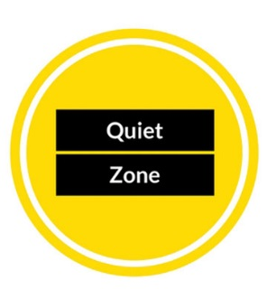
5/ System longevity – Vertical stacked fan coils use a hydronic coil so the system can survive regulatory changes to refrigerants. It is common for these systems to be operating after 30+ years of service.

6/ Ease of maintenance – the best regular maintenance is a quarterly filter change.

7/ Energy savings – occupancy sensors and window and/or sliding glass door interlock are standard control options. Variable speed EC motors and backward inclined impeller fans have reduced the fan energy of a one ton unit from 70 watts to an annualized average of less than 20 watts.

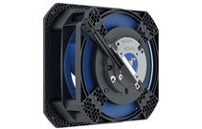

ECM BI Impeller Fan

8/ Minimal space requirements – stacked fan coils use the smallest footprint of any floor mount equipment.

16
17% smaller
footprintt
16” x 16” Footprint for 400CFM Unit
17% smaller
footprintt
17% smaller
footprintt
17% smaller
footprintt

9/ Low first cost –stacked fan coils ease of manufacturing shipping, and installation give them an installed cost advantage over many other single zone terminal units.
Vertical Stacked Fan Coils in Dormitories (Applications)
Figure 1 illustrates a typical modern dormitory suite layout. Colleges and universities prefer the system because the facility can be served by their central chilled water and heating plants for efficient heating and cooling and maintenance can be performed by entering the mechanical closet from the main hallway as opposed to the student suites. This also reduces noise levels by separating and changing the RA path. The mechancial room closet acts as a return plenum with a return air tranfer grill from the suite area. OA can also be added to the closet from a DOAS, or if using the closet as a plenum is not desired, a short RA duct run into the side or back of the unit, below the drain pan can also be accomodated.

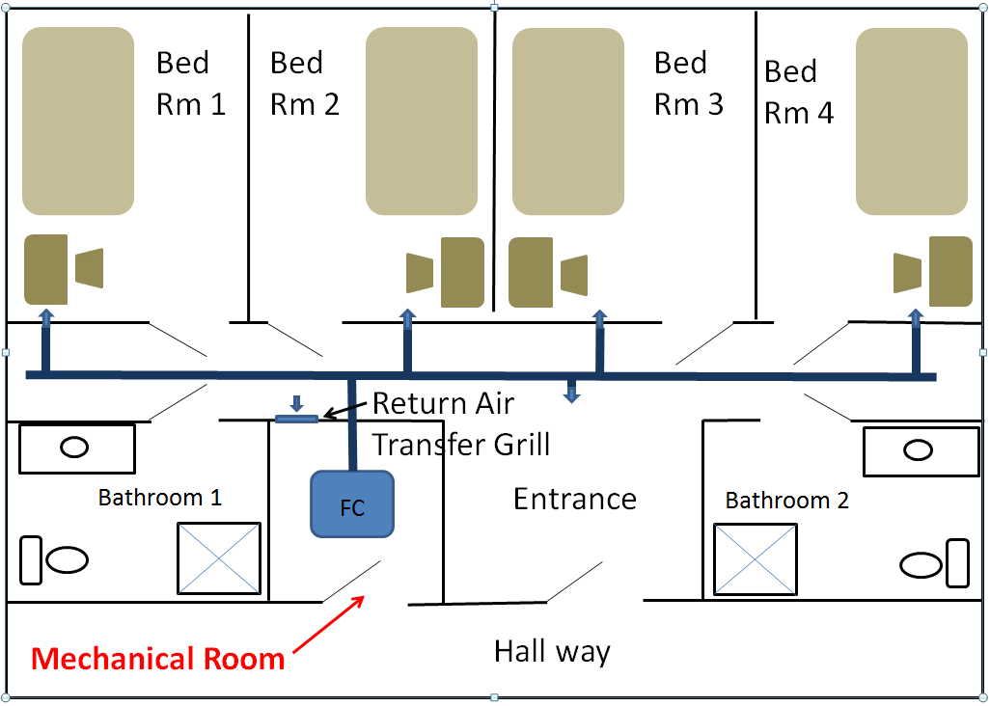Figure 1

Summary
Vertical stacked fan coils are a cost effective life cycle solution where individual space control and low or variable occupancy is typical.

This system, coupled with an air to water 4-pipe energy recovery heat pump and high efficiency DOAS (dedicated outdoor air unit), will provide a reliable, efficient carbon free 30+ year solution for your dormitory.

Contact Temspec Sales for more information.

